CSS file will now get scoped if we rename css file to .module.css. The “.module” naming pattern is basically a signal for the underlying build process. So for the “vite” build tool will process the file differently.

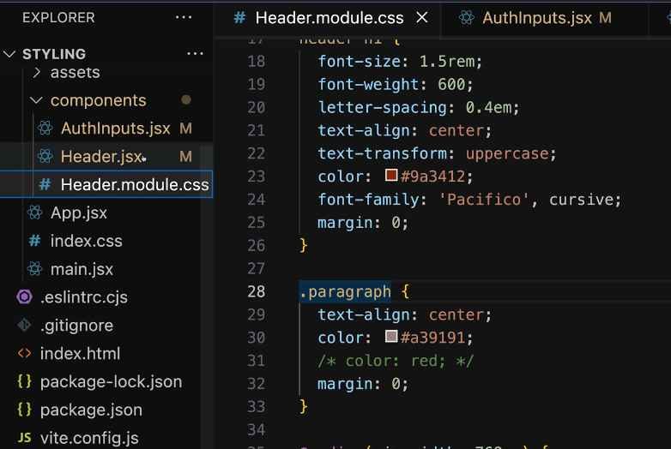

So we also have to import it differently

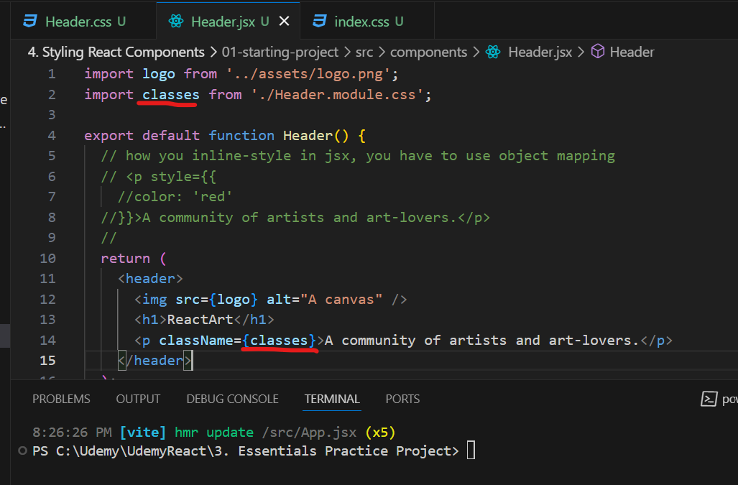

Also, we have an alternative way. We will import “styled” components. Then use a special syntax to create a separate div with specific styling here.

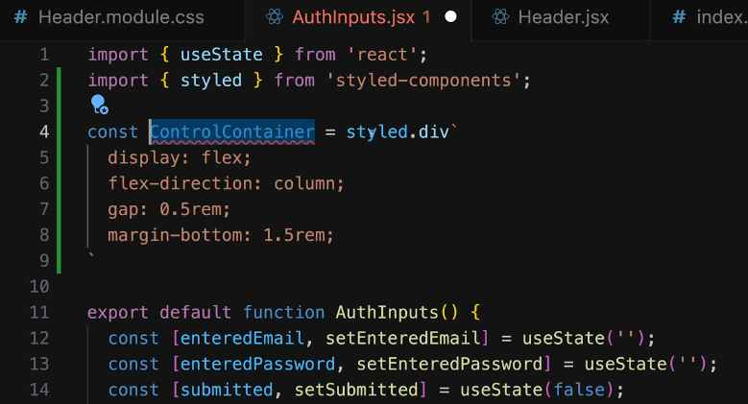

Then use it as a custom component. Like <ControlContainer/>.

We could also set style dynamically with “styled” component with this “invalid” prop.

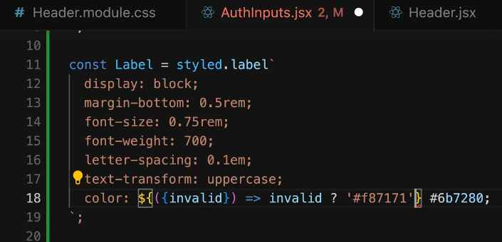

You could also add all sub-element styling to “styled” component by placing all CSS code inside then replace the “element itself” with “&”. In this case, “header” element has been replaced with “&”.

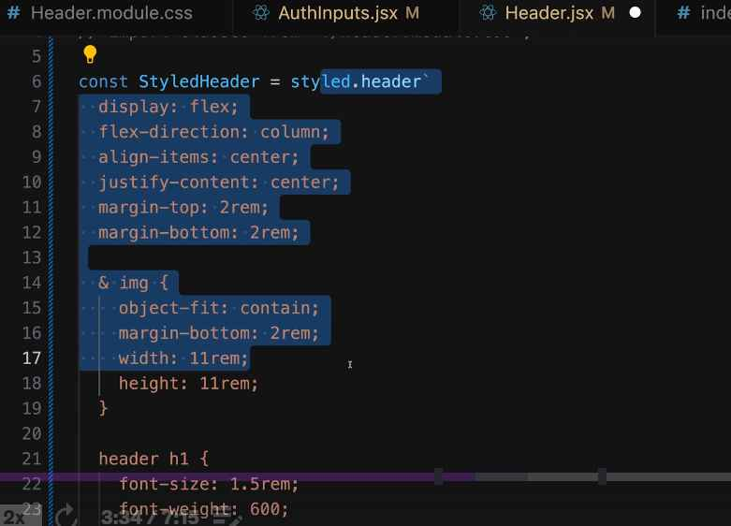

One thing to note that we should also have component file even though it’s only CSS. It’s better for code management.

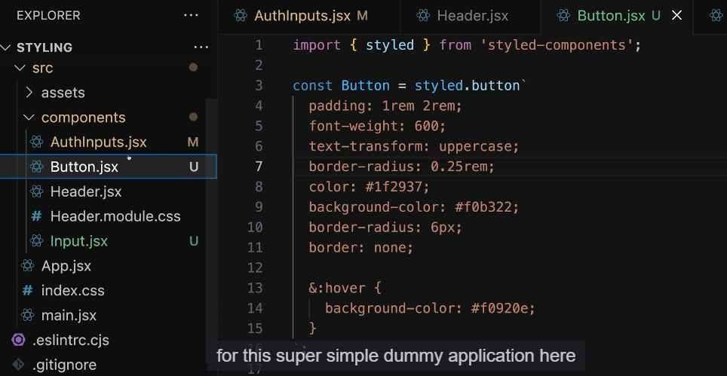

We could also style conditionally with styled component like this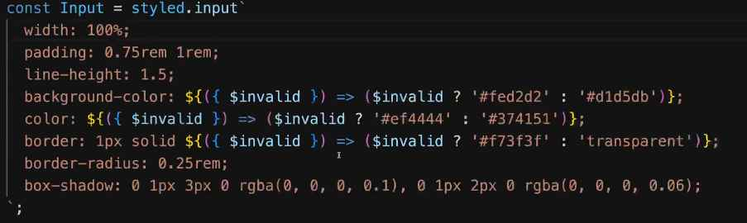

This is how you import tailwind css

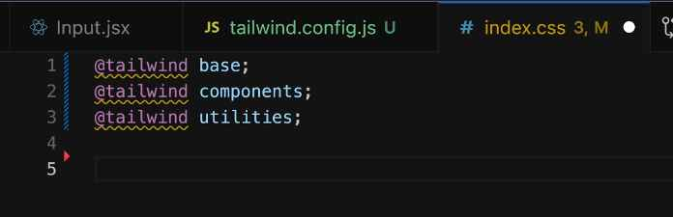

Add new font

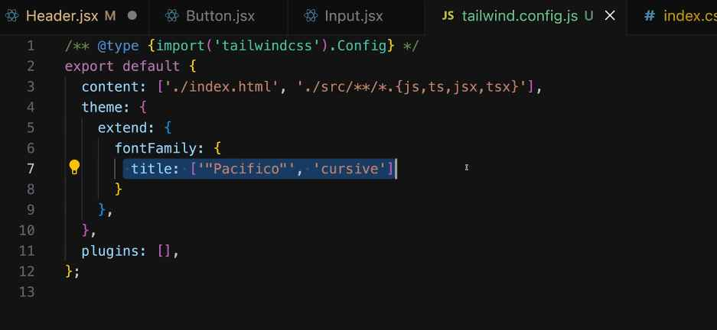

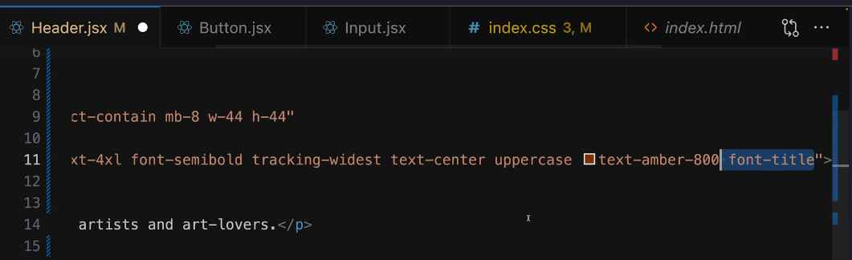

Style conditionally with Tailwind

